Database Documentation

# E-COMMERCE DB

This documentation provides a detailed explanation of the purpose and relationships of each table in the E-Commerce API.

# ERD

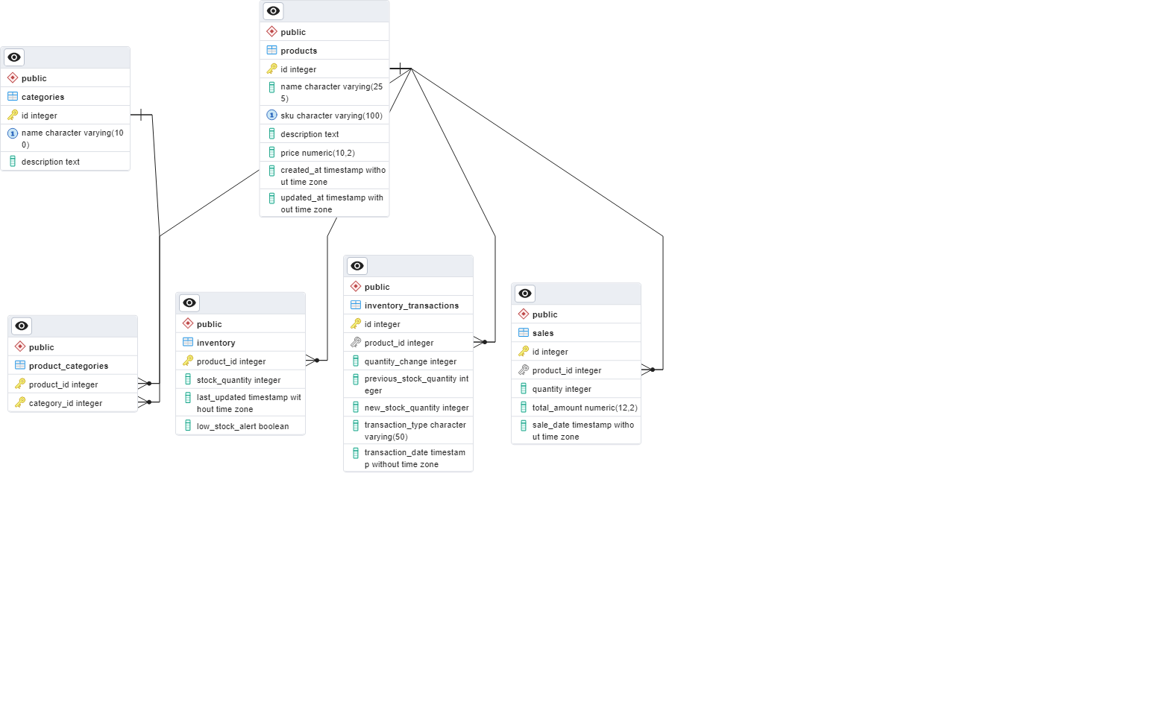

## Tables & Relation

### Products

Stores product information and has a many to many relation with categories with the help bridging product_categories table

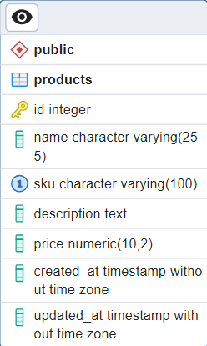

### Categories

Defines categories for organizing products and it has a many to many relation with products with the help of bridging table product_categories

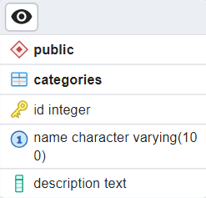

### Product_Categories

Links products to multiple categories

FK : product_id -> products.id

FK : category_id -> categories.id

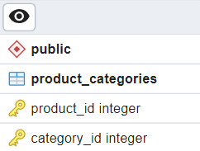

### Inventory

Tracks stock quantity and low stock alerts

FK : product_id -> products.id

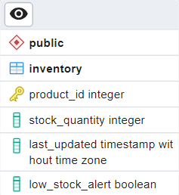

### Inventory_Transactions

Logs inventory adjustments, including restocks and sales

F.K : product_id -> products.id

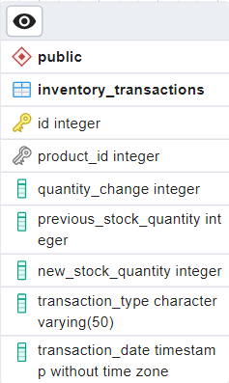

### Sales

Logs sales transactions for products

F.K : product_id -> products.id

### Entity Relation Summary

**Products ↔ Categories** → Many-to-Many (product_categories)

**Products ↔ Inventory** → One-to-One (inventory)

**Products ↔ Inventory Transactions** → One-to-Many (inventory_transactions)

**Products ↔ Sales** → One-to-Many (sales)